1. **INTRODUCTION**

**1.1 Overview**

Air transport is one of the fastest modes of public transport which connects international boundaries. Air transport allows people from different countries to cross international boundaries and travel other countries for personal, business, medical, and tourism purposes.

**1.2 Purpose**

Air transport allows people from different countries to cross international boundaries and travel other countries for personal, business, medical, and tourism purposes.

1. **PROBLEM DEFINITION & DESIGN THINKING** 
   1. **Empathy map**

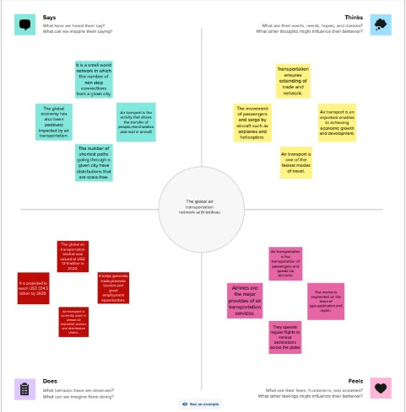

* 1. **IDEATION AND BRAINSTORING MAP**

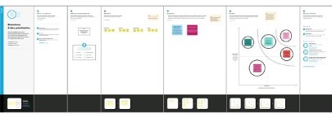

1. **RESULTS**

It includes such as Airports Final, Number of Airports, Airports at higher altitude within a country, Airports at higher altitude in the world, Airlines within a country, Country with Maximum Numbers of Airports, Number of Flights from Airports and etc…. 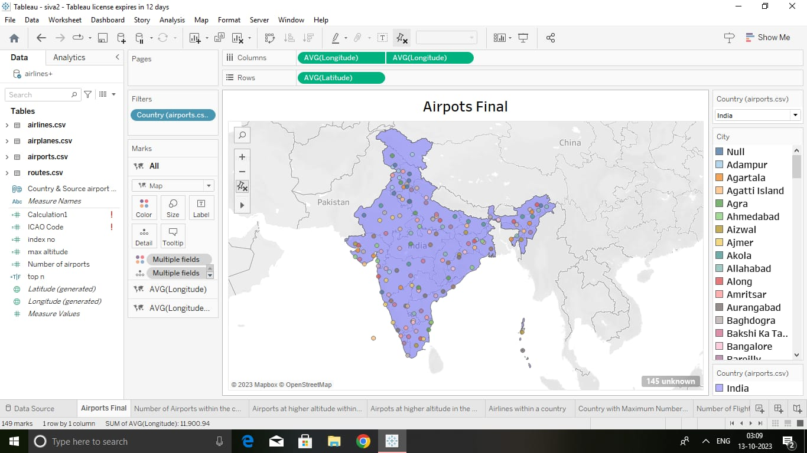

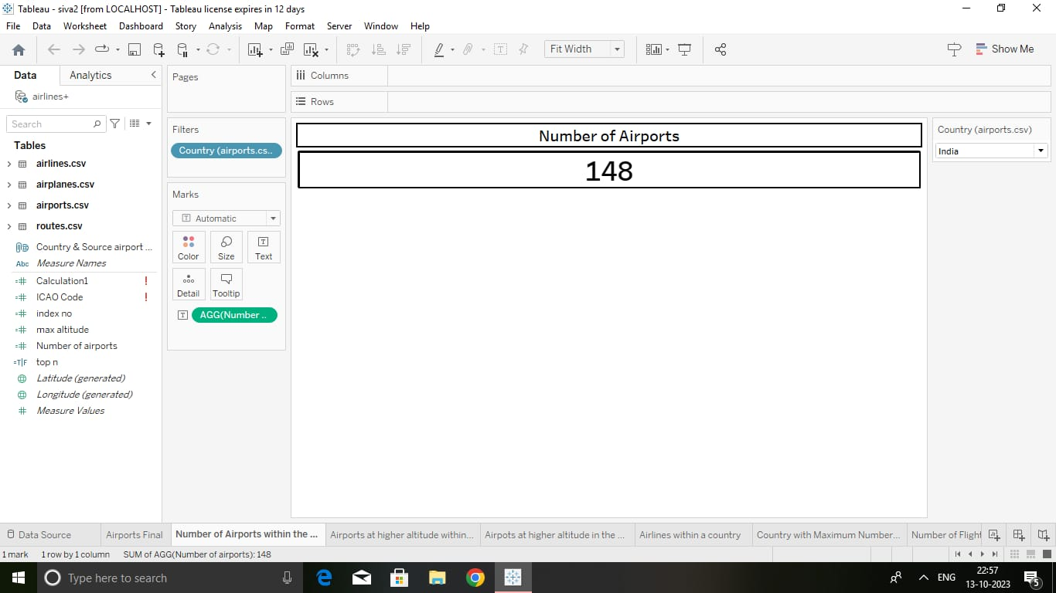

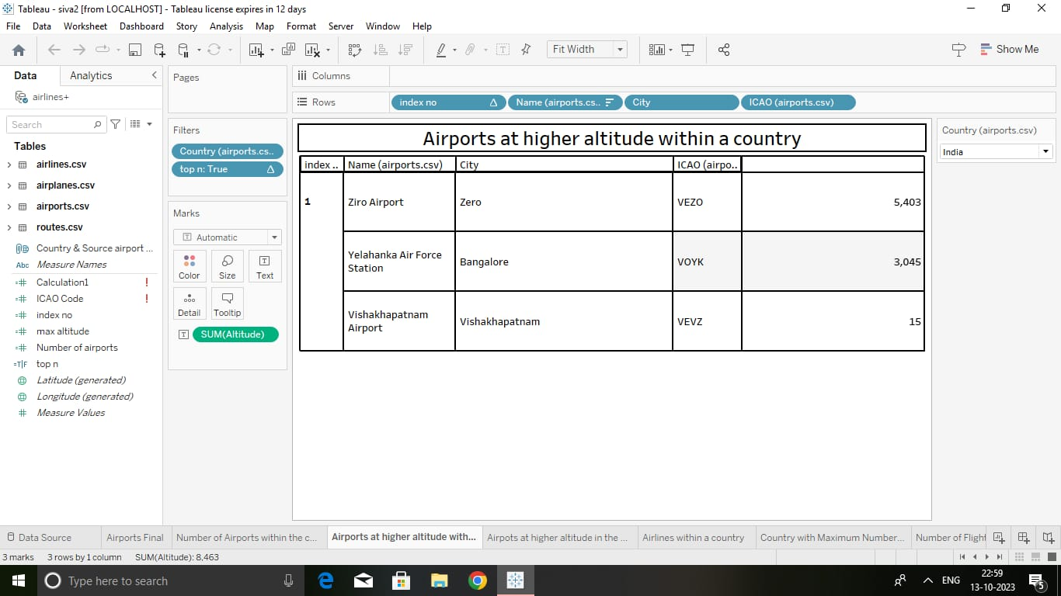

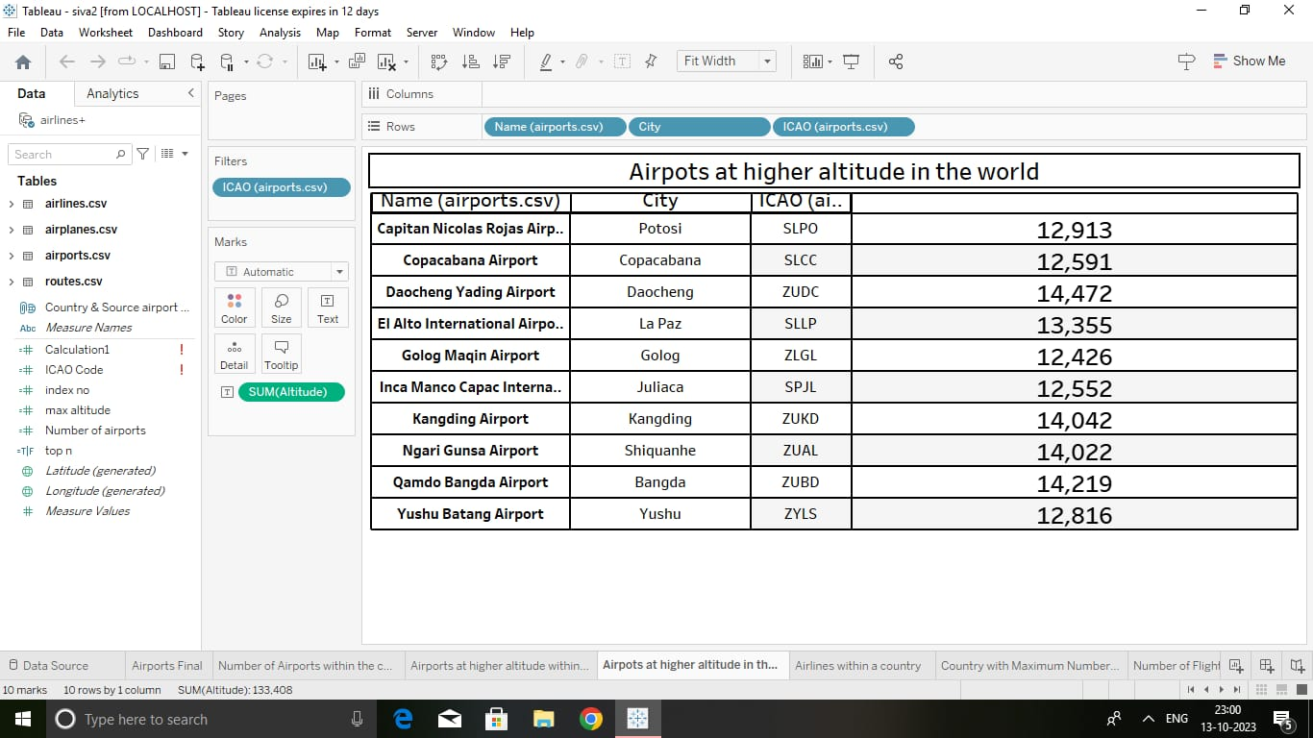

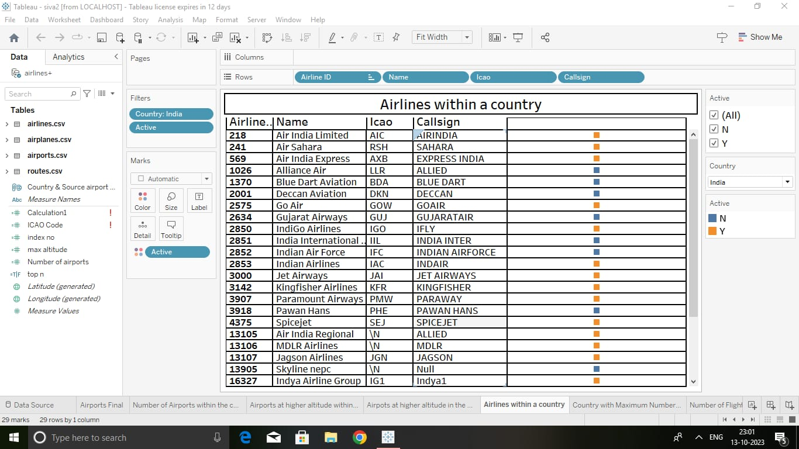

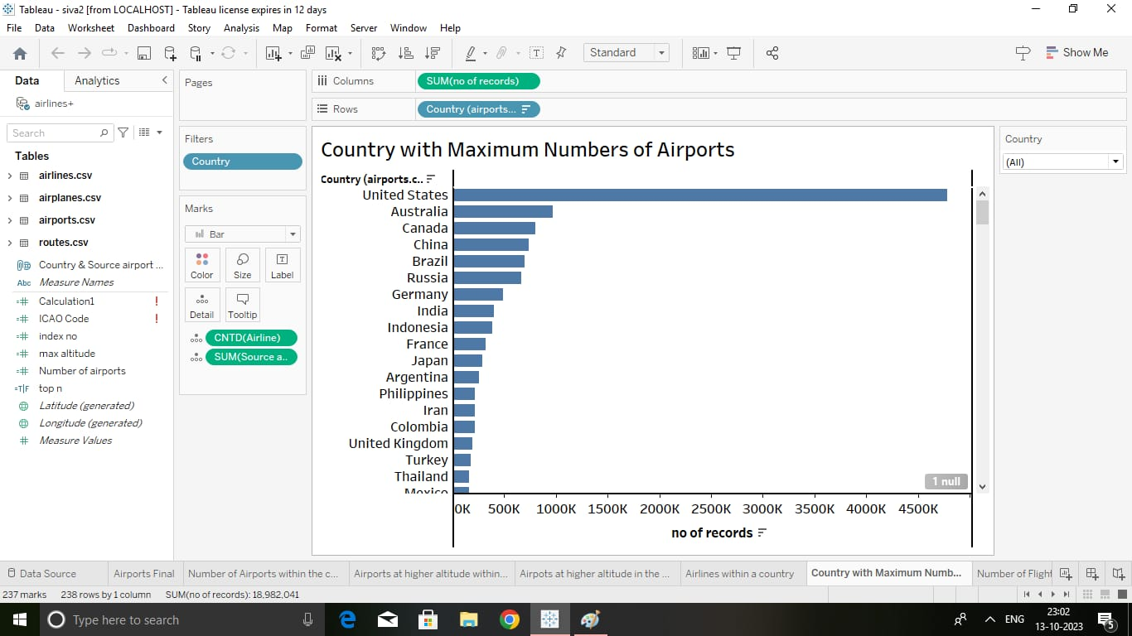

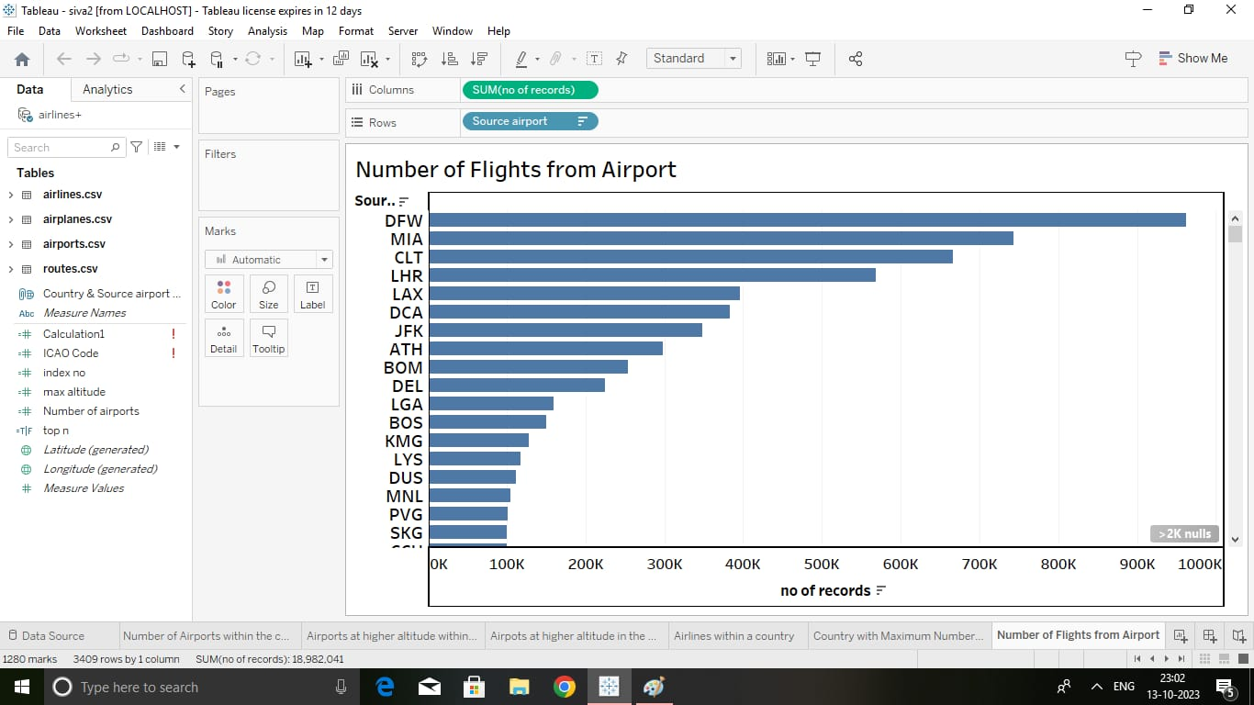

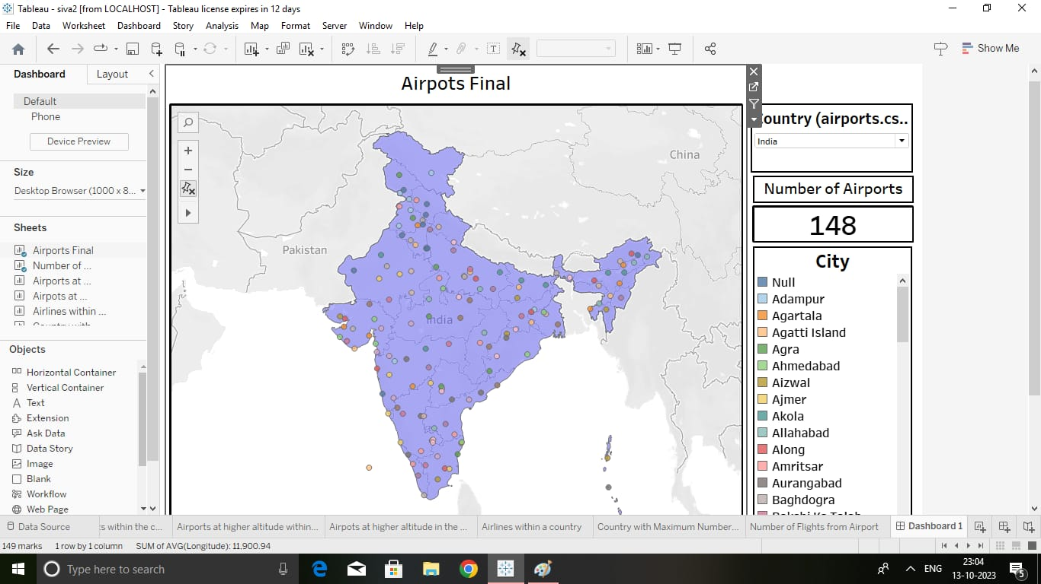

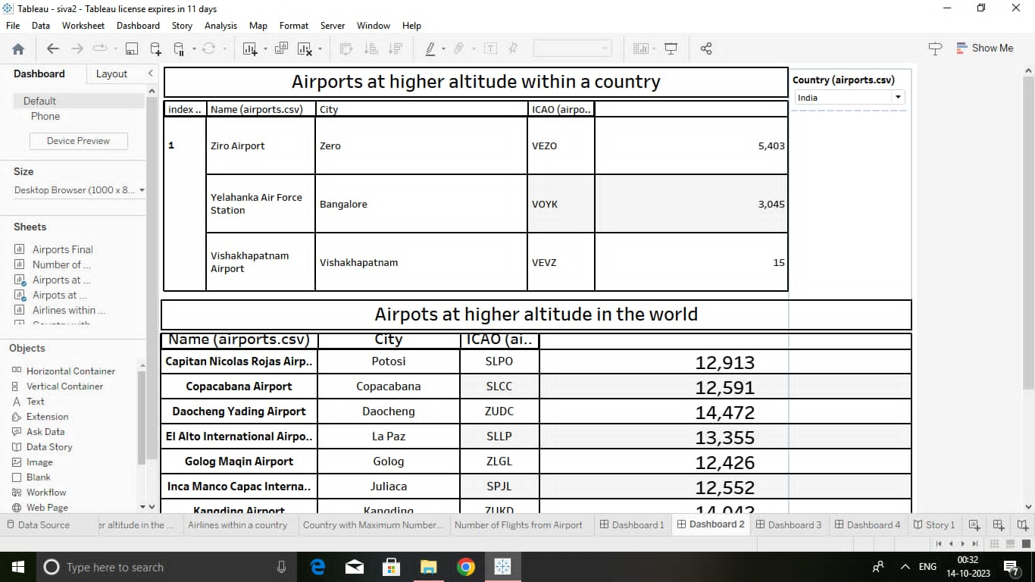

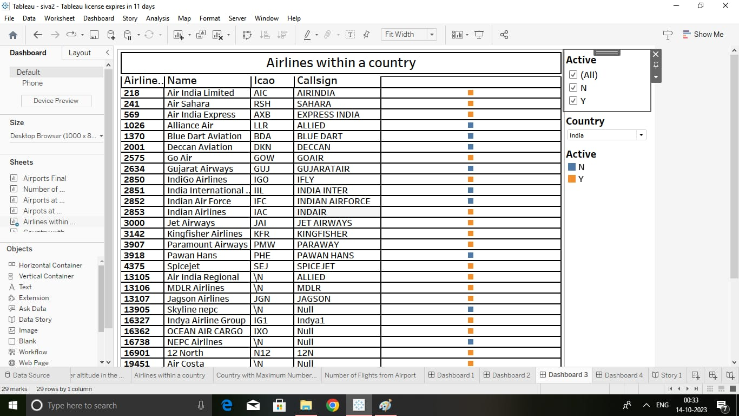

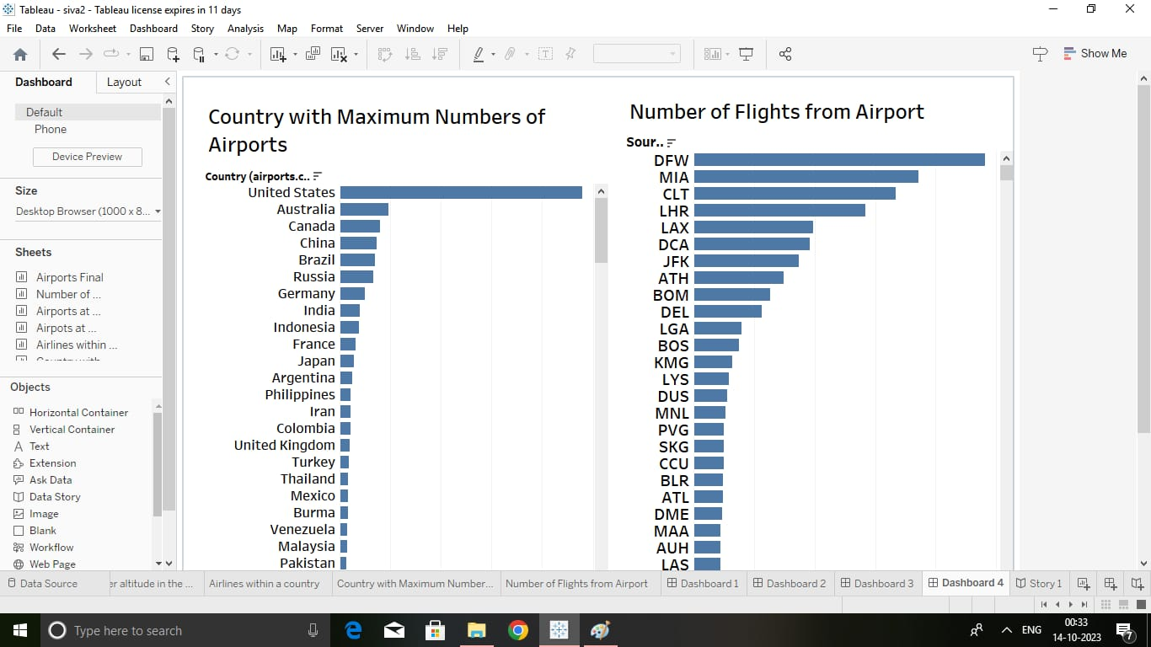

1. **ADVANTAGES AND DISADVANTAGES**

**Advantages**

Speed and Efficiency: One of the key advantages of air transport is its unparalleled speed. Airplanes can cover long distances in a matter of hours, enabling businesses to deliver goods quickly, especially for time-sensitive orders. This swift transportation option is particularly beneficial for industries such as e-commerce, pharmaceuticals, and perishable goods.

**Disadvantages**

Airplanes have limited cargo space compared to ships or trains. This limited capacity can pose challenges for businesses dealing with bulky or oversized shipments. Air transport is best suited for high-value, time-sensitive goods that require swift delivery, rather than large-volume shipments.

1. **APPLICATIONS**

It is used for various purposes, such as business and leisure travel, the delivery of time-sensitive goods, and emergency response and rescue missions.

1. **CONCLUSION**

The air transport industry is not only a vital engine of global socio-economic growth but is also of vital importance as a catalyst for economic development in most countries and for many regions within each country.

1. **FUTURE SCOPE**

The most recent estimates suggest that demand for air transport will increase by an average of 4.3% per annum over the next 20 years. If this growth path is achieved by 2036 the air transport industry will then contribute 15.5 million in direct jobs and $1.5 trillion of GDP to the world economy.